1. Salesforce Changes (Salesforce Team)
   * Create the new case record-type called as “Work item”
   * Define a new panel on the Work Item called as “Jira Issue Updates”
   * Create\Define all the fields on the “Work item” as done on DTQA2 in the “Jira Issue Updates” Panel as below

|  |  |  |  |
| --- | --- | --- | --- |
| S. No | Label Name | Type | Default Value |
| 1 | Jira Project | Jira Project |  |
| 2 | Jira Issue Key | Text(10) |  |
| 3 | Business Unit (New) | Picklist |  |
| 4 | Jira Assignee | Text(50) |  |
| 5 | Performance Testing | Picklist |  |
| 6 | Jira Severity | Picklist |  |
| 7 | Defect Cause | Picklist |  |
| 8 | Jira Release | Lookup(Jira Project) | Not-Required |
| 9 | Product Code (New) | Picklist |  |
| 10 | Jira Status | Text (50) |  |
| 11 | Jira Priority | Picklist |  |
| 12 | Target Release Date | Date |  |
| 13 | Environment | Picklist |  |
| 14 | Test Phase | Picklist |  |

Refer below screenshot

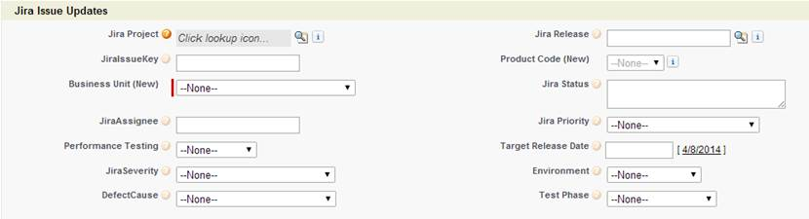

* + Define all the values for **Type** dropdown as in DTQA2
  + Share the credentials for the API access for Production with Jira team
  + Add the button on the “**Work Item**” screen called as “**Create/Update JIRA**” and add the code. Refer to the code in DTQA2. Note (the URL should be pointing to [**http://10.134.8.13:8080/**](http://10.134.8.13:8080/)**.........................**)
  + Enable the trigger which will set the Jira Project Name based on the Jira Issue Key (Zishan\Nidhi have the complete details)

1. Jira Changes (Ness Team)
   * Install the plugin for Project & Release syncup on Prod Jira
   * Install the Salesforce \ Jira connector on PROD
   * Configure all the Jira\Salesforce Fields
   * Create the new screen scheme on PROD to add the additional tab for Salesforce in switched off mode. We will apply this scheme on the day we will announcement PROD rollout.

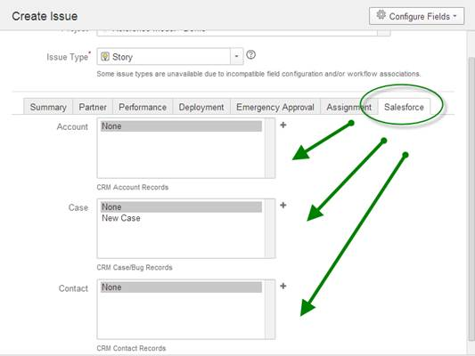

* + Test the Jira screens to make sure there are no performance issues
  + Test the bi directional integration by creating a dummy case